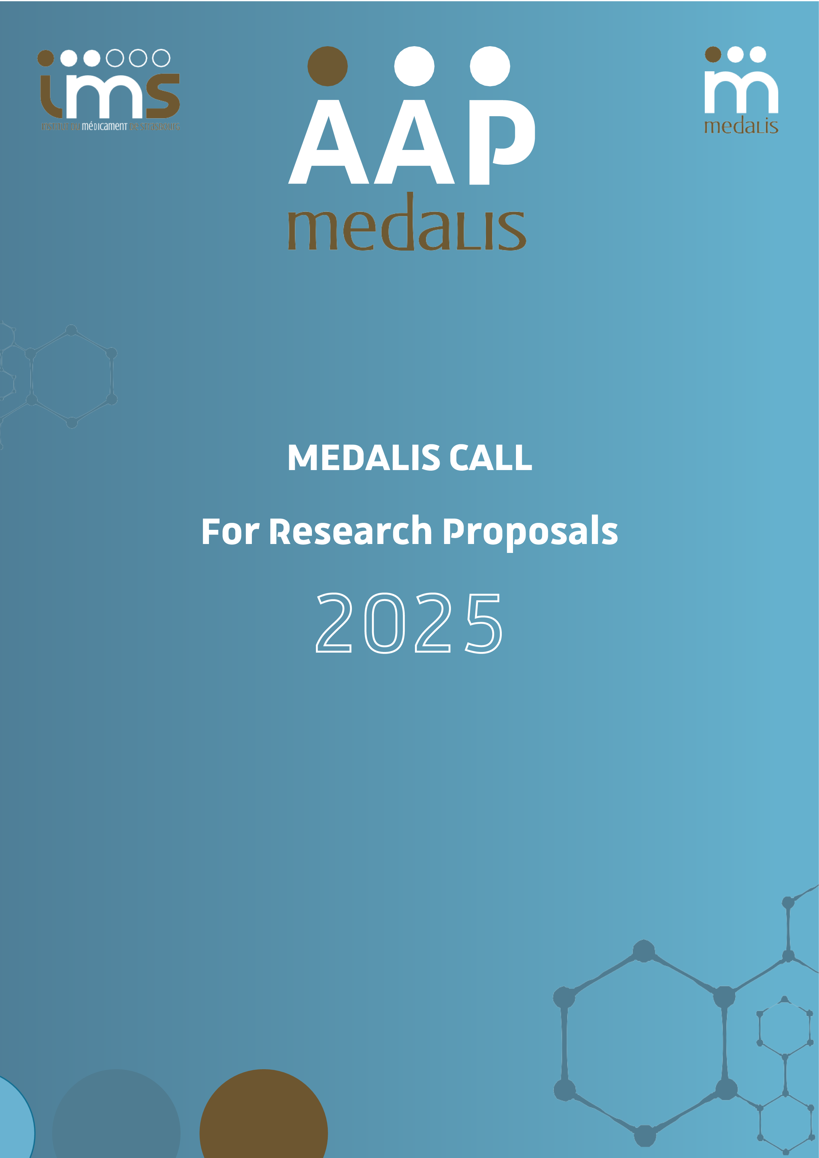


Instruction for Authors

The Strasbourg Drug Discovery and Development Institute (IMS) is based on 3 pillars federating research activities (Medalis), training (EURidis) and innovation / technology transfer (INEdis), all centered on the discovery and development of new drugs.
Twelve academic research teams form the IMS, each providing conceptual and technological bases for therapeutic innovation and having demonstrated previous activity of valorization / transfer. Thanks to a recognized fundamental research activity and an integral part of national and international networks, IMS aims to develop ﬁnalized projects from the entire Strasbourg scientiﬁc community, ranging from in silico studies to setting up of preclinical studies, the creation of intellectual property, the setting up of industrial partnerships and the creation of companies. The ﬁeld of interest focuses on small molecules and peptides for therapy, diagnosis and inherent technologies.
Website : https://ims.unistra.fr/
- ELIGIBILITY
The Medalis call for proposal is willing to ﬁnance several excellent research projects dealing with development of active molecules/new concepts in any therapeutic areas. Are also eligible technological projects/ development of original cellular in vitro or in vivo animal models, which could accelerate the development of innovative therapeutics and diagnostic. The project must have a short/medium term strategy of patent(s) applications and/or start-up creation.
The project must include at least one of the Medalis partners listed in appendix 1. The principal investigator must be member of one of the Medalis team. Collaborations with researchers outside of these teams are possible but will be funded through the principal investigator (no money transfer).
Priority will be given to the most innovative project(s) and those, which mark a break with everything that preceded them. Projects already benefiting, or downstream, a SATT/CNRS maturation, are ineligible for the IMS call for projects.
Remember that a project is more appreciated if it has a multidisciplinary nature and that several IMS leaders are involved.
- FORMAT
A single PDF has to be sent to Ghislain AUCLAIR via email : gauclair@unistra.fr
- GRANT
Medalis offers the possibility to finance two types of projects :
Exploratory grant : Maximum 75k euros over 12 months
Consolidated grant : Minimum of 2 teams including a least 1 Medalis team, for a maximum of 18 months and maximum 300k euros
The grant must be exclusively used to fund the selected project. Grantees undertake to present the project once a year to the Scientiﬁc committee (CS).

An “Exploratory” project is a project without proof of concept or patent filing. It allows to explore a new concept and analyze its possible valorization.
A “Consolidation” project can follow an exploratory project which proves promising. A “Consolidation” project can also be directly submitted if preliminary results have already been obtained. The eligibility criteria of a “consolidation” project include the achievement of a proof of concept at least in vitro, as well as the patentability/valorization study of the project results (to be provided with the file).
Renewal of the subvention can be authorized pending consumption of at least 90% of the inital subvention.
- ELIGIBILITY COSTS
o Operating costs (consumables, reagents, animals etc…)
o Mission expenses related to the project (travels, etc…)
o Equipment
o Subcontract costs (externalization of experiments, production etc...)
- Recruitments on temporary work contract (post-docs, engineers but not PhD students…) of persons who are strictly assigned to the project can be authorized only after using the human manpower of the IMS engineer team (see appendix 2).
- PLANNING AAP 2024 : deadline – 20th June 2024, 20pm

The project has to be written in English and mention the following items :
Title of project / Acronym
Amount leader name
Email
Phone
Company leader name
Email
Phone
Duration in months
Starting date expected
Ending date expected
Project already funded ? If yes, by who ?
Other IMS parteners
Other parteners
Links with Medalis projects ?

- Project abstract (maximum 250 words)
- Project description (maximum 5 pages)
- Duration in months as well as starting & ending dates
- Project already funded by Medalis (Yes or No)
Please, indicate the remaining funding amount at the date of the submission, and if the project started with the DDD challenge.
- If yes, please join a short summary of the last phase of the project as an appendix
- Total cost of the project :
- Amount requested from Medalis :
- Collaboration with Medalis Partners (see appendix 1) :
- Collaboration with other partners (names, institutions, cities, countries) :
- Other financial support(s) granted to this project (Name, amount, period) :
Don’t forget to mention the referees we should no contact due to conflict of interest !

Please include in the description : the scientific background (including preliminary data and proposed innovation), the medical need, the competition, the interdisciplinary character of the project, the expected results, the envisioned transfer.
Specifically for Technological project, please include : Who are the intended users, for what type of application projects, what possible benefits for the IMS.
- Decision tree (work package, go/no go, timeline, cost/work package, alternatives in case of no go…)
Go / No Go
WP2
WP1
WP1 : X months, Y k€, description
WP2’ time
Description
WP2 :…, WP2’ :…
X k€

- Financial summary of the project (see Appendix 3)
- APPENDIX 1 : Medalis partnersgtgrg
Partner Medalis | Name | Email | Unit
1 | Sylviane MULLER | Sylviane.muller@unistra.fr | UMR 7242
2 | Christopher MUELLER | c.mueller@ibmc-cnrs.unistra.fr | UMR 3572
3 | Dominique BONNET | dominique.bonnet@unistra.fr | UMR 7200
4 | Frédéric BIHEL | frederic.bihel@unistra.fr | UMR 7200
5 | Frédéric SIMONIN | frederic.simonin@unistra.fr | UMR 7242
6 | Françoise DANTZER | francoise.dantzer@unistra.fr | UMR 7242
7 | Guilhem CHAUBET | chaubet@unistra.fr | UMR 7199
8 | Dominique BAGNARD | bagnard@unistra.fr | ERL 1321
9 | Pascal VILLA | pvilla@unistra.fr | UAR 3286
10 | Sarah CIANFERANI | sarah.cianferani@unistra.fr | UMR 7178
11 | Frédéric BOISSON | frederic.boisson@iphc.cnrs.fr | UMR 7178
12 | Alexandre DETAPPE | a.detappe@icans.eu | UMR 7178
- APPENDIX 2 : IMS engineer team
BIOLOGY
Cellular & Biology
- Cell culture (adherent lines, stem cells in suspension, primary culture)
- Culture of brain organoids
- Histology (vibratome and cryostat sections)
- Immunohistochemistry & immunoﬂuorescence
- Transfection (JET PEI, Mirus) & Infection (lentivirus)
- Production & puriﬁcation of proteins
- Angiogenesis test
- ELISA, MTT, MTS, Western Blot
- Flow cytometry (FACS & Macs Quantify)
- Duolink (ligature proximity test)
- Xcelligence (proliferation and migration test)
In Vivo Models
- Cancer models (brain tumors, breast tumors, metastases, Multiple sclerosis, Inflammation)
- Pain
- Biodistribution
Molecular Biology & Biochemistry
- RTqPCR, cloning, site-directed mutagenesis
CHEMISTRY
- Medicinal chemistry, chemistry of fluorine, sulfur & phosphorus
Purification
- Chromatography on silica gel (manual and automated), distillation, recrystallization
Analyzes
- NMR (1D and 2D), HPLC, GC, MS, IR, LC/MS
Software
- NMR (1D & 2D), HPLC, GC, MS, IR, LC/MS
PROTEOMIC
Proteomic Analysis by Mass Spectrometry
- Sample preparation : Electrophoresis gels, gel digestion, protein assay, cell lysis, tryptic digestion, puriﬁcation, desalting
- Mass spectrometry : LC-MS/MS, timsTOF Pro, Q Exactive HF-X, label-free quantiﬁcation (spectral count and XIC), de novo analyzes
- Software : HyStar, otof Control, Xcalibur, Chromeleon, Mascot, Proline, Skyline, MaxQuant
MICROFLUIDIC
Micromanufacture
- CAD (Clewin, Autocad)
- Photolithography (MJB3) of negative and positive photoresists
- Microengravings on glass in RIE
- Micropatterning of cells on glass coverslips
- Manufacture of microﬂuidic chips in PDMS
- Coupling micropatterning and microﬂuids
Microfluidic
- Cell cultures and co-cultures in microﬂuidic chips
- Microﬂuidics of drops
Analyzes
- ImageJ
- Matlab
- Graphpad Prism
Others
- 3D prints
- Microengravings
- Laser cutting
- Arduino
BIOINFORMATIC
Informatic
- R programmation
- Linux
- Rmarkdown
- Jupyter
- Docker
- Git
Single cell
- CellRanger
- Seurat
- SOUPX
- Scrublet
- Multidimensional data analysis methods (PCA, t-SNE, UMAP)
- Functional enrichment (GO, Reactome, KEGG, GSEA)
- GEO data analysis and integration
- Cellular repertoire analysis
- Cellular trajectory analysis (Monocle, RNA Velocity, scVelo)
- Cell-cell interaction and communication (CellChat, etc.)
Bulk RNA sequencing
- Quality control (FASTQC)
- Trimming (trimomatic, cutadapt, URQT)
- Indexation and mapping (HISAT2, STAR)
- Gene count (Rsubread), Gene expression (Kallisto)
- Differential Expressing genes (DESeq2).
Whole Genome/Exome sequecing
- Data preprocessing: FastQC, Cutadapt, Trimmomatic
- De Novo Assembly: AbySS, Mapping
- Quantification of reads: Bowtie, BWA
- GATK preprocessing (GATK)
- Germline Variants calling (haplotypecaller )
- Somatic Variants calling (mutect2)
- Variants annotation (SnpEff / Annovar)
- Copy number analysis (FACETS).
The cost of the Innovation engineer does not include the cost of his operating costs (use of platform, materials, etc.) which must therefore be duly budgeted in the financial request and sent to his manager. If human resources (CDD) are planned with the financing request, specify why it is necessary in addition to an IMS engineer (CDI).
Financial summary of the project :
Academic partner |  |  | Cost in euros (with VAT)
Operating costs
(included platform costs (ex : chemistry = 500€ / month)
Equipment costs (Equipment is defined for material costs > 4000 euros HT per unit. A quote has to be sent with the application form for equipment cost > 20 000 euros HT).
Please, indicate a name and a reference
Equipment 1
Equipment 2
Equipment 3
Subcontract costs
Travel costs
Personnel cost
Please, indicate the position title (post-doctorate,..)
TOTAL PROJECT Partner 1
Partner n° (you can add more partners) |  |  | Cost in euros
Operating costs
Platform costs (ex : chemistry = 500 euros / month)
Equipment costs (Equipment is defined for material costs >4000 euros HT per unit. A quote has to be sent with the application form for equipment cost > 20 000 euros HT).
Please, indicate a name and a reference
Equipment 1
Equipment 2
Equipment 3//
Subcontract costs
Travel costs
Personal costs
Please, indicate the position title (e.g. post-doctorate, Engineer)
Total Project Partner n° (you can add more partners)
Total project (75k euros max)
Other personnel costs (included in the 75k euros global cost)
IMS engineer team  Cell biology  Microfluidic  Proteomic  Chemistry | Number of month | Part time (%) | 5000*(x months)*%
Project leader name

Signature

